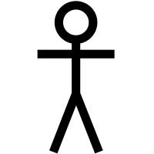

My App

**Video Game Player**

Edit settings

Choose a level

Quit game

Access in game menu

Close in game menu

Exit Level

Edit setting in game

Look around

Walk

Slow walk

Run

Crouch

Jump

Climbing ladders, ropes, and chest high objects

Open doors

Pick locks

Opening combination locks

Picking up objects

Steal objects off of enemies

Look through inventory

Use Items in inventory

Knock out enemies

Putting out lights

Use buttons and switches

Finish Level

Lose level

View score after level

Exit to main menu

Continue to next level